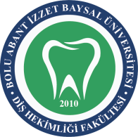 | BOLU ABANT İZZET BAYSAL ÜNİVERSİTESİ DİŞ HEKİMLİĞİ FAKÜLTESİ  ……………………. ISI VE NEM TAKİP FORMU |  |  | 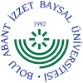
DOKÜMAN KODU | YAYIN TARİHİ | REVİZYON NO | REVİZYON TARİHİ | SAYFA NO
SAH.FR.12 | 11/03/2019 | 1 | 02.02.2026 | 1/1

TARİH | ORTAM ISISI |  | ORTAM NEMİ |  | KONTROL EDEN AD-SOYAD | İMZA
TARİH | SABAH  08.00 | AKŞAM  16.00 | SABAH  08.00 | AKŞAM  16.00 | KONTROL EDEN AD-SOYAD | İMZA
......./......../20.....
......./......../20.....
......./......../20.....
......./......../20.....
......./......../20.....
......./......../20.....
......./......../20.....
......./......../20.....
......./......../20.....
......./......../20.....
......./......../20.....
......./......../20.....
......./......../20.....
......./......../20.....
......./......../20.....
......./......../20.....
......./......../20.....
......./......../20.....
......./......../20.....
......./......../20.....
......./......../20.....
......./......../20.....
......./......../20.....
......./......../20.....
......./......../20.....
......./......../20.....
......./......../20.....
......./......../20.....
......./......../20.....
......./......../20.....

